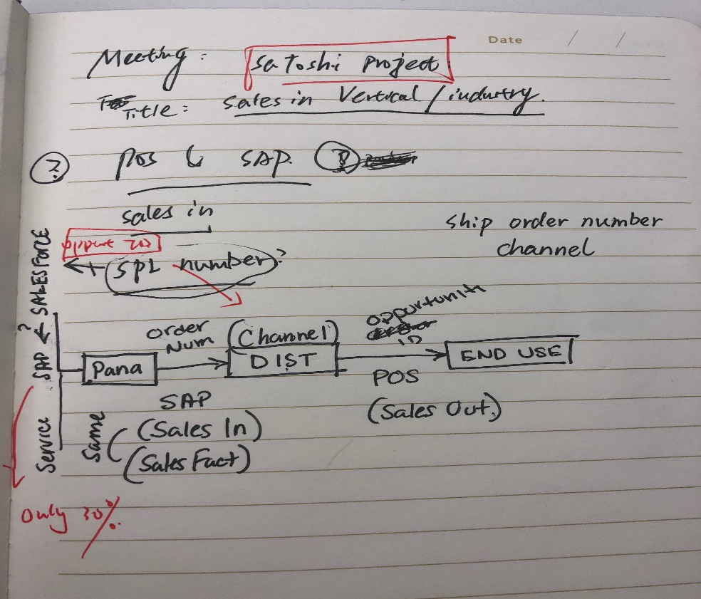

Location:

Model:

Connect Solution-> Data Model-> Strategic Deployment-> Revenue Module 9/25

Connect Solution-> WIP Project-> Strategic Deployment ->Install Revenue Test Report

FRSG -;..

Let’s talk about status of current reports (Accruals – stability of Ariba Data) works in process (Profitability) and future requirements not yet started (McDonalds Experience of The Future.)

we will start with food services reporting and add to your workload from there.

Subject: FRSG Installation Profitability

Create report that combines SAP, HEAT and ARIBA data to ascertain profitability by individual program, project etc. Provides the business visibility to programs that are not profitable and should be discontinued or improved upon.

Status: Started but stalled. Needs to be created in Cognos. We have created manual a few times in Excel.

Subject: McD “Experience of the Future” (EOTF) initiativeHelps assign resources needed for select McDonalds stores that have been reassigned for corporate initiatives. Goal here would be a geographical representation of a resourcing needs, based on weekly time periods of Sunday through Saturday.Status: Not started

Definition:

Call ID == Work Order Number == Ticket

Project has multiple Call ID

SAP order has multiple Call ID

Po ID( multiple Call ID to one Po ID)

Supplier- ---------> PNA------ --> Distributor

PO ID SAPOrder

Sales fact

SAP Ariba Heat(SQL)

Revenue Costs order details

Called no called yes called yes

Order number yes order number no order yes

Material (SAP)

SAP Order (Isgheat Detail)

Call ID (Isgheat Detail)

Item (Call Log)

Billed Amount (Sales fact) sell machine get money

Paid Amount (Ariba install table) Actual paid for install worker

Amount Invoiced (Ariba install table) supposed to be paid money from worker

Gross Profit (Billed- Paid)

Po Spend (before the transaction, what we think we should get)

Accrual Amount = PO Amount - Paid Amount ( the gross profit by imagination)

Works:

Run total to the call id for all numerical values.

What is Po Description Call Id (A)?

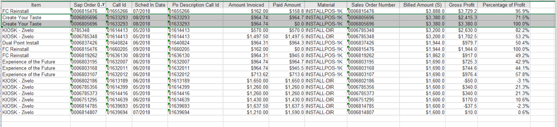

Gather at the SAPOrder level.

There are duplicate in the Blue table.

SAPOrder CallID 1 values

CallID 2 values

But for SapOrder, there are 6 counts. ( we need apply none to values(Paid Amount) to kill du.)

(7 ) Item: Install - Material start with Ins

Project – Material start with Proj

Staging – Material start with Stag

Procedure:

Because

Billed Amount (from SAPOrder Level)

Amount Invoiced (CallID Level)

Paid Amount (CallID Level)

Need manually created summed Paid and Invoiced Values based on SAPOrder.

Then calculate the Gross Profit.

Then create the Pivot Table

Pivot Query in the Cognos are wrong. Create by hands.

Need delete all the blank titles. Because those are all products.

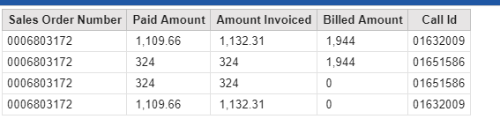

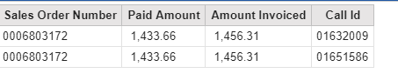

From Sales Order Line -> Sales Fact with Bill Amount(set None)

